**PSG College of Technology, Coimbatore-04**

**Department of Applied mathematics and Computational Sciences**

**20XC28 – Python Programming Lab**

**Problem Sheet – IV - Functions**

1. Write a function that computes a future investment value at a given interest rate for a specified number of years. The future investment is determined using the formula:



Use the following function header:

**def futureInvestmentValue( investmentAmount, monthlyInterestRate, years):**

For example: futureInvestmentValue(10000, 0.05/12, 5) returns 12833.59.

Write a test program that prompts the user to enter the investment amount and the annual interest rate in percent and prints a table that displays the future value for the years from 1 to 30. Here is a sample run:



1. A supermarket awards coupons depending on how much a customer spends on groceries. For example, if you spend $50, you will get a coupon worth eight percent of that amount. The following table shows the percent used to calculate the coupon awarded for different amounts spent. Write a program that includes a function to calculate and print the value of the coupon a person can receive based on groceries purchased.

Here is a sample run:

Please enter the cost of your groceries: 14

You win a discount coupon of $ 1.12. (8% of your purchase)

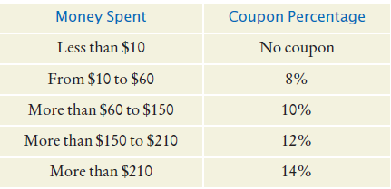

1. Having a secure password is a very important practice, when much of our information

is stored online. Write a program that validates a new password, following these rules:

• The password must be at least 8 characters long.

• The password must have at least one uppercase and one lowercase letter

• The password must have at least one digit.

Write a program that asks for a password, then asks again to confirm it. If the passwords don’t match or the rules are not fulfilled, prompt again. Your programshould include a function that checks whether a password is valid.

1. A laboratory container is shaped like the frustum of a cone.

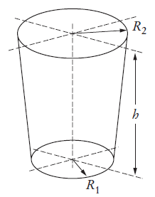

Write functions to compute the volume and surface area, using the following equations.

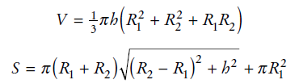

1. If you have 3 straws, possibly of differing lengths, it may or may not be possible to lay them down so that they form a triangle when their ends are touching. For example, if all of the straws have a length of 6 inches, then one can easily construct an equilateral triangle using them. However, if one straw is 6 inches long, while the other two are each only 2 inches long, then a triangle cannot be formed. In general, if any one length is greater than or equal to the sum of the other two then the lengths cannot be used to form a triangle. Otherwise they can form a triangle. Write a function that determines whether or not three lengths can form a triangle. The function will take 3 parameters and return a Boolean result.
2. Write two functions, hex2int and int2hex, that convert between hexadecimal digits (0, 1, 2, 3, 4, 5, 6, 7, 8, 9, A, B, C, D, E and F) and base 10 integers. The hex2int function is responsible for converting a string containing a single hexadecimal digit to a base 10 integer, while the int2hex function is responsible for converting an integer between 0 and 15 to a single hexadecimal digit. Each function will take the value to convert as its only parameter and return the converted value as the function’s only result. Ensure that the hex2int function works correctly for both uppercase and lowercase letters. Your functions should end the program with a meaningful error message if an invalid parameter is provided.
3. Many companies use telephone numbers like 555-GET-FOOD so the number is easier for their customers to remember. On a standard telephone, the alphabetic letters are mapped to numbers in the following fashion:

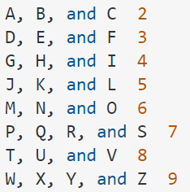

Write a program that asks the user to enter a 10-character telephone number in the format XXX-XXX-XXXX. The application should display the telephone number with any alphabetic characters that appeared in the original translated to their numeric equivalent using a function. For example, if the user enters 555-GET-FOOD the application should display 555-438-3663.

1. Craps is a popular dice game played in casinos. Write a program to play a variation of the game, as follows:

Roll two dice. Each die has six faces representing values 1, 2, ..., and 6, respectively. Check the sum of the two dice. If the sum is 2, 3, or 12 (called craps), you lose; if the sum is 7 or 11 (called natural), you win; if the sum is another value (i.e., 4, 5, 6, 8, 9, or 10), a point is established. Continue to roll the dice until either a 7 or the same point value is rolled. If 7 is rolled, you lose. Otherwise, you win.

Your program acts as a single player. Here are some sample runs.









1. Write a function with the following header to format the integer with the specified width.

**def format(number, width):**

The function returns a string for the number with prefix 0s. The size of the string is the width. For example, format(34, 4) returns "0034" and format(34, 5) returns "00034". If the number is longer than the width, the function returns the string representation for the number. For example, format(34, 1) returns "34".

Write a test program that prompts the user to enter a number and its width and displays a string returned from invoking format(number, width). Here is a sample run:



1. Write a recursive function that implements the recurrence relation to calculate the nth power of an integer value x. Both n and x should be parameters to the function. The return value of the function will be value of xn.

For example: if n=4 and x=2 the function should return 24=16.

1. Write a C program to implement the recursive Ackermann’s function as given below.

N+1 , if M = 0

A ( M,N) = A ( M-1, 1), if N = 0

A (M-1, A(M, N-1)), Otherwise.

Find the result of the following values using this recursive function. A(0,0),A(0,9),A(1,8),A(2,2),A(2,0),A(2,3),A(3,2),A(4,2),A(4,3),A(4,0).

1. Write a recursive function that returns the value of the following recursive definition.

f(x,y) = x-y if x or y < 0

f(x,y) = f(x-1,y) + f(x,y-1) Otherwise.

1. Write a program that computes and displays the charges for a patient’s hospital stay. First, the program should ask if the patient was admitted as an in-patient or an out-patient. If the patient was an in-patient the following data should be entered:

* The number of days spent in the hospital
* The daily rate
* Charges for hospital services (lab tests, etc.)
* Hospital medication charges

If the patient was an out-patient the following data should be entered.

* Charges for hospital services (lab tests, etc.)
* Hospital medication charges

The program should use two functions *in_patient()* and *out-patient()* to calculate the total charges. One of the functions should accept arguments for the in-patient data, while the other function accepts arguments for out-patient data. Both functions should return the total charges.

*Input Validation: Do not accept negative numbers for any information*

1. An International Standard Book Number (ISBN) is used to uniquely identify a book. It is made of 10 digits as shown below.

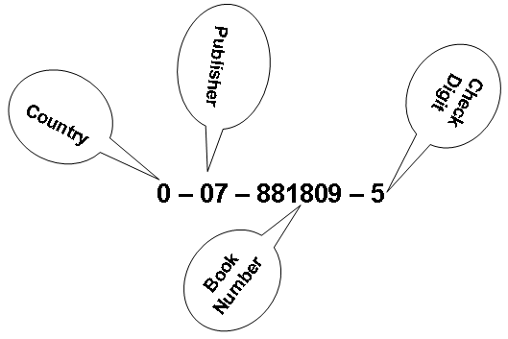

Write a function *test()* that tests an ISBN to see if it is valid. For an ISBN number to be valid, the weighted sum of the 10 digits must be evenly divisible by 11. The tenth digit may be x, which indicates 10. To determine the weighted sum, the value of each position is multiplied by its relative position, starting from the right, and the sum of the product is determined. The calculation of the weighted sum for the ISBN number in the figure is given below.

|  |  |  |
| --- | --- | --- |
| **Code** | **Weight** | **Weighted Value** |
| 0 | 10 | 0 |
| 0 | 9 | 0 |
| 7 | 8 | 56 |
| 8 | 7 | 56 |
| 8 | 6 | 48 |
| 1 | 5 | 5 |
| 8 | 4 | 32 |
| 0 | 3 | 0 |
| 9 | 2 | 18 |
| 5 | 1 | 5 |
|  | **Weighted sum** | **220** |

Since, the weighted sum modulus 11 is 0, the ISBN number is valid. Test your program with the given ISBN number and 0-08-781809-5(an invalid ISBN).

1. A magic date is a date where the day multiplied by the month is equal to the two digit year. For example, June 10, 1960 is a magic date because June is the sixth month, and 6 times 10 is 60, which is equal to the two digit year. Write a function that determines whether or not a date is a magic date. Use your function to create a main program that finds and displays all of the magic dates in the 20th century.